Requirement Analysis

**Submitted By : Muhammad Saaim 50441**

**Group Members:**

|  |  |  |
| --- | --- | --- |
| **Name** | **Student ID** |  |
| **Syed Rafay Hussain** | **51381** |  |
| **Osama Abdullah** | **50442** |  |
| **Muhammad Saaim** | **50441** |  |

## **REQUIREMENT ANALYSIS**

Customer Requirement:

Web Application

Desktop Application

Database between Web and Desktop Application

* **FUNCTIONAL AND NON FUNCTIONAL REQUIREMENTS**

|  |  |  |  |  |
| --- | --- | --- | --- | --- |
| **No.** | **Requirement** | **Feature** | **SS/**  **CS** | **F/**  **NF** |
| 1 | Client (desktop app) needs to be always connected to the server. | All | CS | F |
| 2 | Client (desktop app) should have an interface for the customer to enter login information. | Login | CS | NF |
| 3 | Client (desktop app) must send login information to the server to be checked. | Login | CS | F |
| 4 | Server (desktop app) must check the sent login information by the client and respond to the client. | Login | SS | F |
| 5 | Client (desktop app) should be able to display list of categories and click on them for browsing. | Menu  category | CS | NF |

|  |  |  |  |  |
| --- | --- | --- | --- | --- |
|  |  |  |  |  |
| 6 | Client (desktop app) must send the clicked category’s identification to the server. | Menu  category | CS | F |
| 7 | Server must provide the selected category’s content list for the client. | Menu  category | SS | F |
| 8 | Client(desktop app) should be able to display a product’s description such as pizza(flavor and size) | View products description | CS | NF |
| 9 | Server must provide the selected product’s description for the client. | View products description | SS | F |
| 10 | Client (desktop app) should have an interface for the customer to add a product to the bill. | Add products to the cart | CS | NF |
| 11 | Client (desktop app) must send the clicked product’s identification to the server. | Add products to the cart | CS | F |
| 12 | Server should add the product to the customer’s bill on the database. | Add products to the cart | SS | F |
| 13 | Server should be able to check a product’s quantity on the database. | Check item quantity | SS | F |
| 14 | Client(desktop app) should have an interface for the customer to remove an already added product on the bill | Remove product from cart | CS | NF |
| 15 | Client (desktop app) must send the removed product’s identification to the server. | Remove product from cart | CS | F |
| 16 | Server should remove the product from customer’s bill on the database. | Remove product from cart | SS | F |
| 17 | Client (desktop app) should have an interface for the customer to change the quantity of an already added product on the bill. | Change quantity | CS | NF |
| 18 | Client (desktop app) must send the new quantity and the product’s identification to the server. | Change quantity | CS | F |
| 19 | Server must update the customer’s bill on the database. | Change quantity | SS | F |
| 20 | Client (desktop app) should have an interface for the customer to checkout and view the checkout receipt. | Checkout | CS | NF |
| 21 | Client must send the customer’s identification to the server. | Checkout | CS | F |
| 22 | Server must provide the customer’s checkout receipt for the client. | Checkout | SS | F |
|  |  |  |  |  |
|  |  |  |  |  |
| List of Abbreviations  No. Number  SS Server side  CS Client side  F Functional  NF Non-Functional  **AS Web Application Side** | |  |  |  |

* **USE CASE DIAGRAM AND ITS NARRATIVES**

**USE CASE DIAGRAM:**

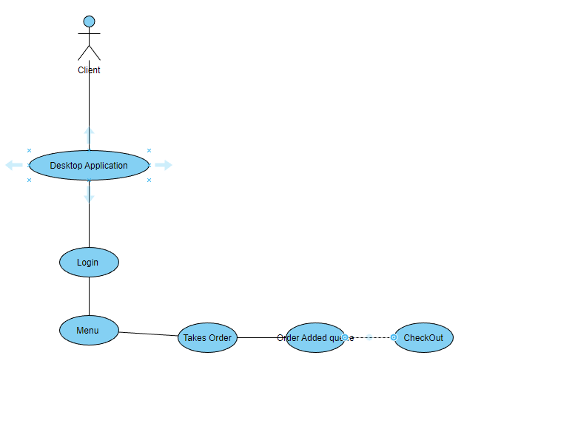

**USE CASE WITH ITS NARRATIVES:**

**Sub use cases with narratives**

* 1. **User Login to the system**

|  |  |  |
| --- | --- | --- |
| **Use Case Name:** | Login(Desktop Application) | |
| **ID:** | OM-01 | |
| **Actors Involved:** | Client | |
| **Brief Description** | Actor enters the email address and password to login to the system. | |
| **Pre-Conditions** |  | |
| **Post-Conditions** |  | |
| **Normal Flow of Events:** | **Actor Action** | **System Response** |
| 1. Enter email address and password. 2. Clicks the submit button. | 1. System displays the actor mail page on successful login. 2. System displays error message on invalid login. |

* 1. **User Adds to Cart(Bill)**

|  |  |  |
| --- | --- | --- |
| **Use Case Name:** | User Cart(Bill) | |
| **ID:** | OM-02 | |
| **Actors Involved:** | Client | |
| **Brief Description** | Actor Adds/Removes products from the cart. | |
| **Pre-Conditions** | OM-01 | |
| **Post-Conditions** | Addition/Removal of products from user cart. | |
| **Normal Flow of Events:** | **Actor Action** | **System Response** |
| 1. Click on “Add to cart” on products 2. Click “Remove” option in the user Bill | 1. System adds the product into the Clients Bill 2. System deletes the product from the Clients Bill. 3. System Resets For new Entry |

* 1. **User makes payment**

|  |  |  |
| --- | --- | --- |
| **Use Case Name:** | Payment | |
| **ID:** | OM-03 | |
| **Actors Involved:** | Client ,Customer | |
| **Brief Description** | Make payment for the product | |
| **Pre-Conditions** | OM-02 | |
| **Post-Conditions** |  | |
| **Normal Flow of Events:** | **Actor Action** | **System Response** |
| 1. Client Provides the Bill to Customer 2. Customer pays the bill | 1. System Generates the Bill |

* 1. **Account Management**

|  |  |  |
| --- | --- | --- |
| **Use Case Name:** | Account Management | |
| **ID:** | OM-07 | |
| **Actors Involved:** | Administrator | |
| **Brief Description** | Manage Product availability and Prices | |
| **Pre-Conditions** |  | |
| **Post-Conditions** |  | |
| **Normal Flow of Events:** | **Actor Action** | **System Response** |
| 1. Add\Delete New Products to the Menu 2. Modify Prices for the Product 3. Enable \Disable Availability of Products | 1. Add\Delete Products to Database 2. Modify rates to Database 3. Modify availability of product. |

* **ENTITY RELATIONSHIP DAIGRAM(ERD)**

**ERD:**

**Description:**

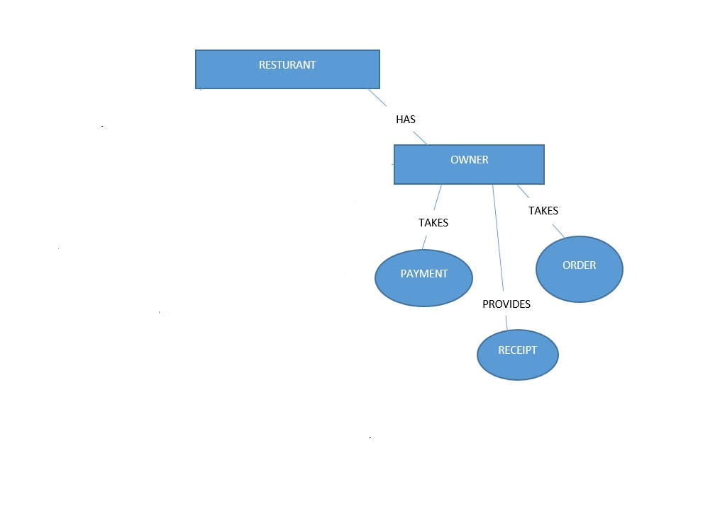

**\*\*\*END\*\*\***